**Boys and Girls Polo Shirts** (Sizes 2T – 4T and Sizes 4-12)

Short Sleeve Polo Shirts -------------------------------------------------------- $6.00

Long Sleeve Polo Shirts --------------------------------------------------------- $7.00

Colors: White, Yellow, Light Blue, Navy and Pink

**Girls Blouses** (Sizes 2T – 4T and Sizes 4-8)

Short Sleeve ----------------------------------------------------------------------- $6.00

Long Sleeve ------------------------------------------------------------------------ $7.00

Colors: White, Yellow, Light Blue

**Girls Skorts** ---------------------------------------------------------------------------------- $8.50

**Girls Skort Jumper** ----------------------------------------------------------------------- $10.00

Colors: Khaki and Navy

**Girls Jumpers** ------------------------------------------------------------------------------ $10.00

Colors: Khaki and Navy

**Boys and Girls Bottoms** (Sizes 2T – 4T and Sizes 4-10)

Pants -------------------------------------------------------------------------------- $10.00

Shorts --------------------------------------------------------------------------------- $8.50

Colors: Khaki and Navy

**Born Again Christian Academy and Preschool**



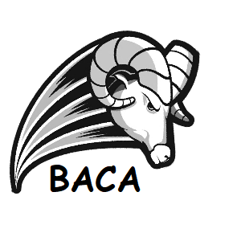

**Uniform Price List**